INSTRUCTIONS FOR PREPARATION OF CONTRIBUTIONS
TO THE CONFERENCE PROCEEDINGS

John AMBER  Civil Engineer  Smith, Good Partners  Louisville, CA, USA  john.amber@goodpartners.com |  | Jane SMITH  Professor  Thames University  London, UK  jane.smith@londonuniversity.uk

Summary (maximum 15 lines)
These instructions have been prepared in the format that should be used for your
- Final Abstract (2 pages)
- Full Paper (max. 10 pages)
for the Footbridge 2011 Conference in Wrocław.
Please refer carefully to this document when you are preparing your contributions.

Keywords: Include a concise list of not more than ten keywords, for example, footbridge; aesthetic; dynamic; structural concepts; planning; new materials; lateral vibration; response; damping.

Introduction
The Conference proceedings will be published as follows:
- Book of Final Abstracts (in colour)
- CD-ROM with all Full Papers
Both will be distributed at the Conference. Authors are required to submit a Final Abstract (2 pages) together with the Full Paper in electronic form. The page limit for the full paper, whether it is presented orally or in a poster session, is eight pages. However, up to ten pages will be accepted if the content of the paper justifies the extension. The CD-ROM will include both the 2 pages abstracts and the full papers.
Guidelines for the preparation and submission of 2 pages abstracts and full papers are given in this document. All text, figures and tables should be placed within an area 170 mm wide and 252 mm high. On A4 paper, this is equivalent to left- and right-hand margins of 20 mm, top margin of 25 mm and bottom margin of 20 mm. The page numbering will be added later by the Publisher. Although manuscripts will be peer-reviewed and may be returned to authors for revisions before publication, initial submissions should be made in final form assuming that no revisions shall be necessary.

Guidelines for Papers / Abstracts

Templates
This document is the template.

First Page
The first half-page should include the Title, information on the Author(s) and the Summary. The Title (Arial Narrow, bold 14, centred) in English should have a maximum of 60 characters, without any abbreviations. Data for each author should be presented on 5 lines only (Arial Narrow 11) including 1) First Name and NAME, 2) Title or Position, 3) Company, 4) City and Country, 5) E-mail address. The Summary, in English, should be a maximum of 15 lines (Arial Narrow 11).
A maximum of ten Keywords (Arial Narrow 11) should be given after the Summary, with an overhanging indent of 20 mm. The paper, in English, begins on the lower half of the first page.

Fonts and format to be used
The following fonts, sizes and spacing should be used, as they are in this document.

Body Text
Body text should be written in Arial Narrow 11 pt, line spacing 12 pt. There should be no hyphenation (cutting words) and the text should be justified.

Headings
Headings should be limited to three levels and numbered appropriately using the decimal system. Main headings
(1. Introduction) should be written in Arial Narrow bold 11 pt, line spacing 12 pt. Subheadings should be written in Arial Narrow bold 11 pt, line spacing 12 pt. Third level headings should be written in Arial Narrow italic 11 pt, line spacing
12 pt. Provide a single line (11 pt) space between the previous section and all headings.

Captions and Lettering in Figures and Tables
The captions of figures and tables should be written in Arial Narrow italic 10 pt, line spacing 12 pt. Lettering used in figures and tables should be large enough to be readable at reduced size (80%), i. e. characters should not be smaller than Arial 9 pt.

Graphics (Drawings and Photographs) and Tables
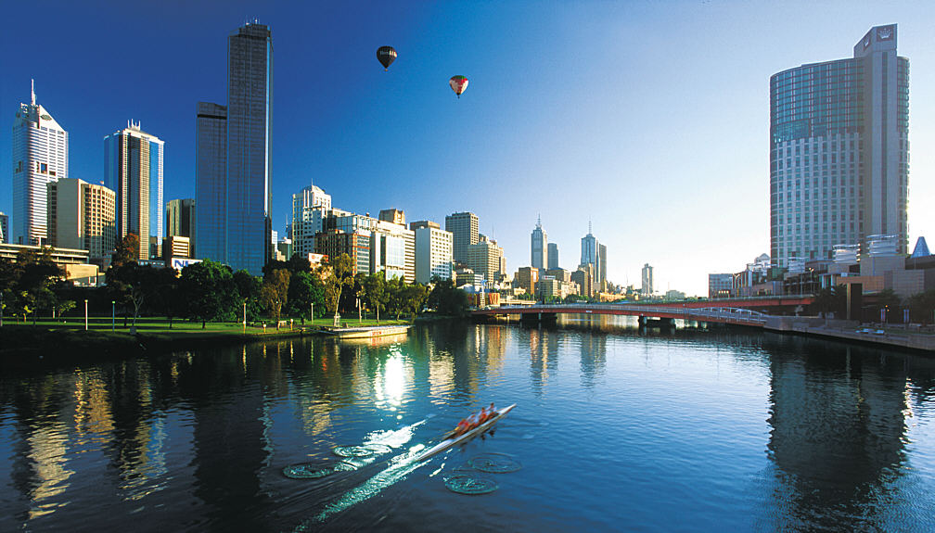
Fig. 1 This is a figure or table caption, italic

[For ease of file transfer, use compact formats for images. The above image has satisfactory resolution in jpeg format (137 kB).]
Create graphs and line drawings electronically, and insert them electronically into the finished document. Photographs should also be inserted electronically into the document.
All figures and tables must be inserted near the location where they are first described. Provide a Fig. number and caption below each figure or photograph and a Table number and caption above each table.
The resolution should be 150x150 dpi (dots per inch) for photographs and 300x300 dpi for drawings. Graphics and tables around which the text is wrapped should be aligned with the left margin and should not exceed 100 mm in width.
Table 3 Results for Axial Load`
Yield Line Number | Normal BM (Nmm) | Yield Line Length (mm)
1 | -13.793 | 5.771
2 | -25.058 | 11.660
3 | -18.315 | 11.832
4 | -10.334 | 11.813
5 | -4.335 | 11.638

Tables should have borders top and bottom and under headings, but not vertical borders. Scanned drawings and tables inserted as bitmaps are not acceptable.

Equations
Insert all equations using the equation editor (integrated in Microsoft Word), as text if possible, or as an image. Equations should be referenced with a number shown in brackets, ( ), to the right of each equation. Here is an example:

 | $$w=\frac{M}{Q}\left\{\frac{\text{sin}\left[k\left(h−x\right)\right]}{\text{sin}\left(\text{kh}\right)}+\frac{x}{h}−1\right\}$$ | (1)

Footnotes
Footnotes should not be used.

Units
Use SI units exclusively.
Decimal location should be indicated by a point “.” and not by a comma “,”.

Discussion, Conclusions and Acknowledgements
The paper should finish with a discussion, final comments and conclusions. Acknowledgements should follow the conclusions if necessary.

References
References should be listed in the order in which they appear in the paper and provided with a reference number in square brackets [1] using an overhanging indentation of 10 mm. References should be made in the paper using the appropriate reference number in square brackets. In the list of references, the author’s names are uppercase and are followed by the initials. The titles of books, journals and proceedings should be in italics. Titles should be in lower and upper case as shown below. The year of publication and the page number(s) should be given.
- ANDERHEGGEN E., DESPOT Z., STEFFEN P., and TABATABAI S.R.M., “Reinforced Concrete Dimensioning based on Element Nodal Forces”, ASCE Journal of Structural Engineering, Vol. 120, No. 6, 1994, pp. 1718-1731.
- NIELSEN M. P., Limit Analysis and Concrete Plasticity, Prentice Hall, New York, 1984, 360 pp.

Submission of Contributions
Papers and extended abstracts should be submitted together by the deadline date of February 15, 2011. Both should be submitted as Portable Document Format files (.pdf) and as Word files (.doc), with the following filenames:

For the Final Abstract
ABS_First Author Surname_Paper ID.pdf (example: ABS_Amber_261.pdf)
ABS_First Author Surname_Paper ID.doc (example: ABS_Amber_261.doc)
Paper ID is a number ascribed to your paper and can be found in “Your Submissions” on ConfTool user account.

For the Full Paper
PAP_First Author Surname_Paper ID.pdf (example: PAP_Amber_261.pdf)
PAP_First Author Surname_Paper ID.doc (example: PAP_Amber_261.doc)

Great attention has to be given to the quality of images, drawings and pictures.

The electronic files should be uploaded in the Conference System (http://www.footbridge2011.pwr.wroc.pl/conftool/).

Alternatively they might be download on FTP server – server address: ftp.wcss.pl, user name: footbridge2011, password: th2011fb.

Two-Page Abstract
The abstracts will be strictly limited to two pages and should be prepared according to these Guidelines. Please keep in mind that the abstracts will be printed in colour in the Conference Book of Final Abstracts and will serve as a summary of your paper. Abstracts will also be included in the CD-ROM, where colour images will be retained.

Full Paper
The full papers should be prepared according to these Guidelines. Papers will be published on a CD-ROM. The first page of papers should preferably be free of tables, figures or photographs.

Author Data
If you are more than two authors adopt the example below and place it at the beginning of this document.
John AMBER  Civil Engineer  Smith, Good Partners  Louisville, CA, USA  john.amber@goodpartners.com |  | Pierre DUPONT  Director  Précontrainte Assoc.  Le Havre, France  pierredupont@precontrainte.fr |  | Shinichi FUJI  Project Manager  Toyo Works Ltd  Osaka, Japan  shinichi.fuji@toyoworks.jp

